For creating Dummy API we are using JSON-Server Module of Node.

>npm I json-server –g

Open VS code and open a particular folder.

Create one file called users.json

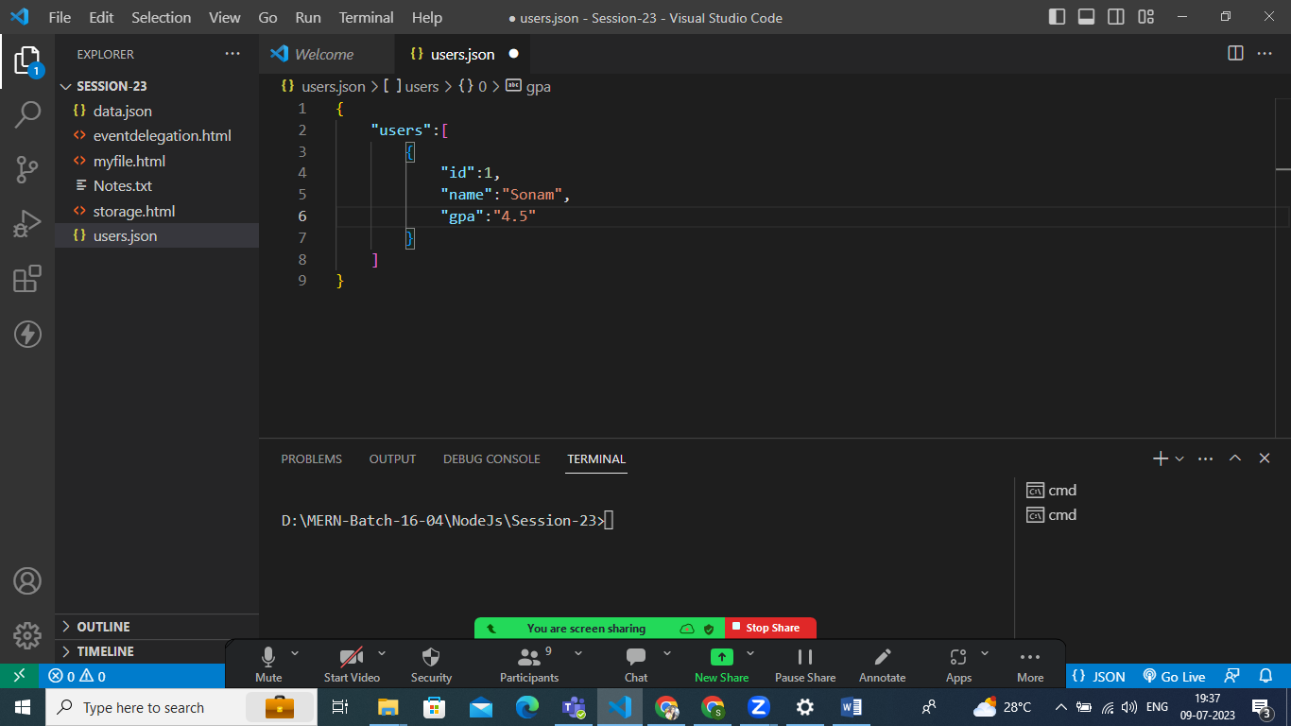

Save the same and start this server from terminal

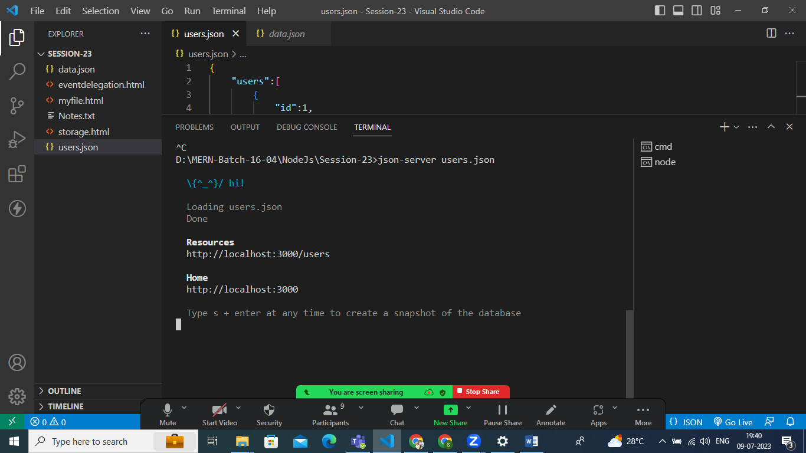

To check the same you can Open browser and open that link

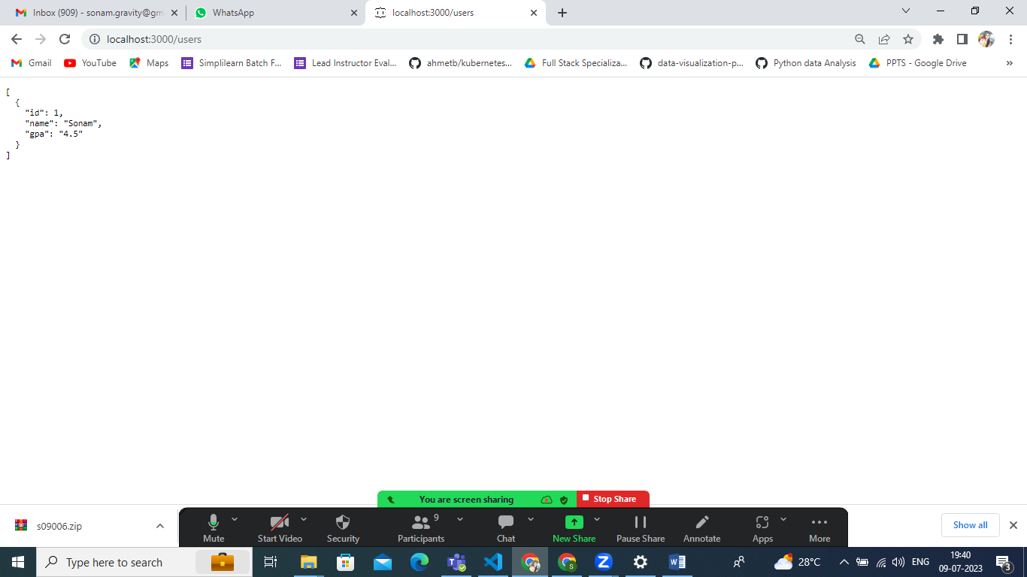

The same you can check from POST MaN

Get Request in POSTMAN

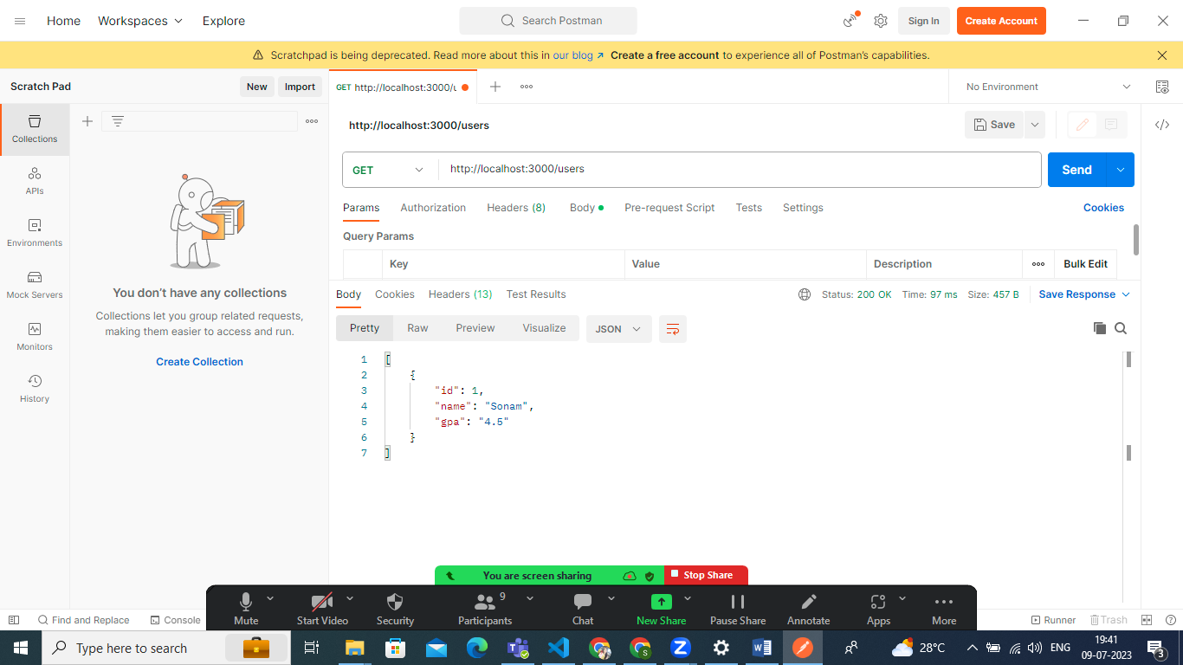

POST Request

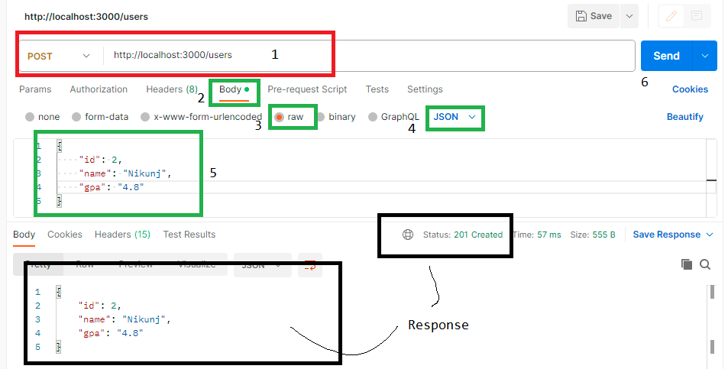

Get By Id only pass Id through URL

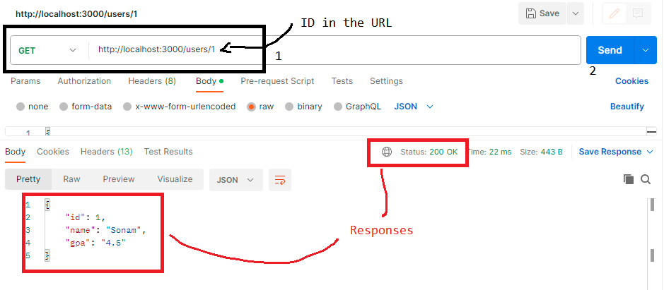

Get By Id but Id not found

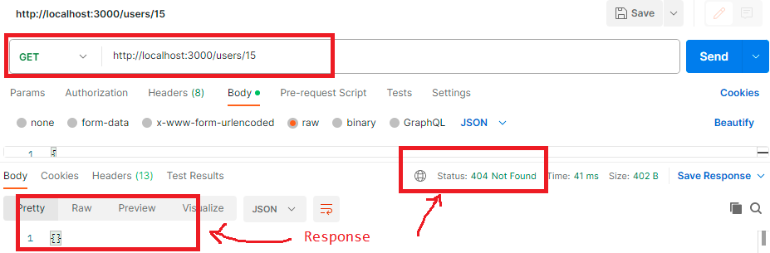

Put Method (update the object which is already available)

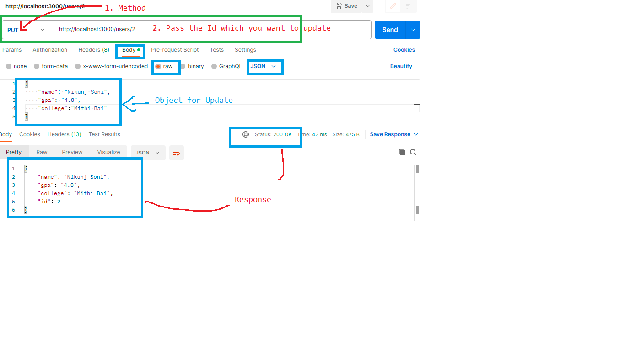

Delete By Id

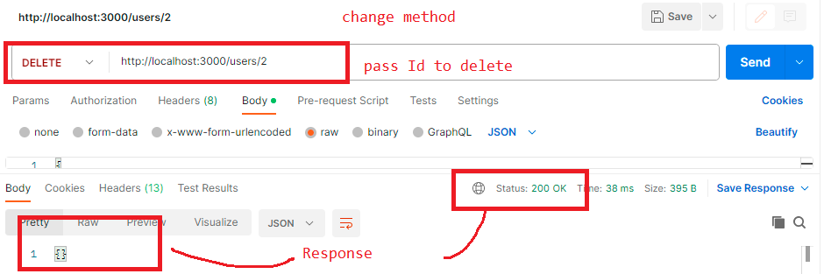

Patch(to update a single value)

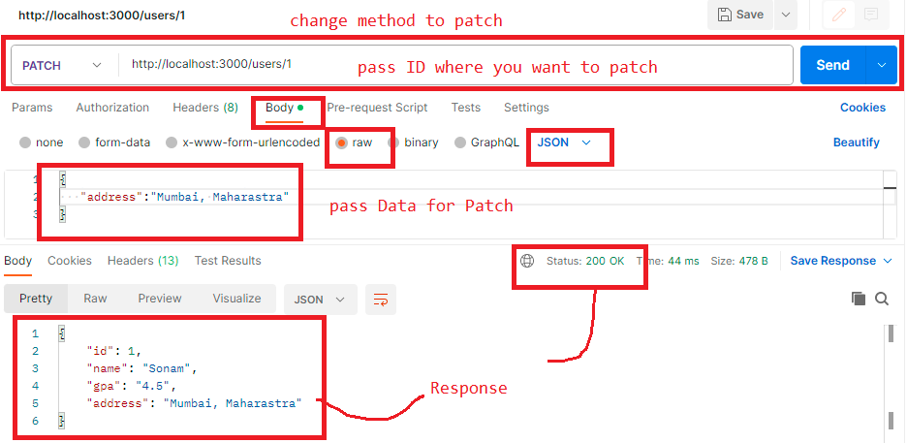

Once this all apis are working fine then Keep your Server Running and Call these APIS from Your HTML or JS code and print your Data in console or in Browser.

For that we will use Fetch API and we can call all the Methods like Get Post Put delete, patch from JS code.

That You can check it from our program.

